**An Update of the Global Entrepreneurship Development Index for Scotland**

Professor Jonathan Levie

Hunter Centre for Entrepreneurship, Strathclyde Business School

Professor Erkko Autio

Imperial College London Business School

Professor Laszlo Szerb

University of Pecs

Final Report

17 October 2017

**Table of contents**

|  |  |
| --- | --- |
| **Section title** | **Page** |
| Section 1: Introduction and Summary of results | 3 |
| Section 2: Literature Review | 4 |
| Section 3. Results of the Global Entrepreneurship Development Index update | 8 |
| Section 4. References | 17 |
| Appendix 1. Original versus revised spider diagrams for 2008 to 2011 | 18 |
| Appendix 2 GEDI Methodology and Calculation of the Scores for Scotland | 22 |
| Appendix 2.1 Country sample | 22 |
| Appendix 2.2 Methodology | 23 |
| Appendix 2.3 Calculation of the Individual and Institutional variables scores | 28 |
| Appendix 2.4. Description of the individual variables used in the GEDI | 30 |
| Appendix 2.5 Description and source of the institutional variables used in the GEDI | 31 |
|  |  |
|  |  |
|  |  |

**Section 1: Introduction and Summary of results**

This report presents a short literature review on academic work on entrepreneurial ecosystems since the first REAP Scotland report followed by the results of an update of the Global Entrepreneurship Development Index for Scotland originally conducted in 2012. A small number of measures used in the original index have been revised because data is no longer available. The periods compared are 2008 to 2011 and 2012 to 2015 and the data used are comparable for these periods.

The literature review demonstrates that significant advances have been made in our understanding of what makes contemporary entrepreneurial ecosystems work. Scotland-based academics have made significant contributions to this literature. Major areas of focus in the literature include information exchange between entrepreneurs in the ecosystem, digitization, job creation and management of entrepreneurial ecosystems.

The index update shows that between the first period and the second period, Scotland’s GEDI profile improved both absolutely and relative to benchmark nations. If it were a nation state, it would rank 5th when included with 28 innovation-driven nations on the GEDI index for the 2012 to 2015 period, comfortably within the upper quartile. This is a rise from number 12 for the 2008 to 2011 period. Scotland’s weakest pillars improved significantly, resulting in a more rounded profile, with no obvious bottlenecks visible. In fact, Scotland’s profile was more balanced than any of the 28 innovation-driven (developed) countries in the sample, just ahead of the United States. As a result, the GEDI methodology may be less accurate as an identifier of weaknesses in Scotland’s entrepreneurial ecosystem for the second period. This should be borne in mind when considering the results of the sensitivity analysis. This suggested that the main points of absolute weakness in the second period, to which around half of any additional policy effort should be directed, were Risk Capital, High Growth and Internationalization.

The updated GEDI analysis suggests that as a whole, the Scottish entrepreneurial ecosystem is remarkably healthy. Some caution is necessary in attributing this improvement to work done by the REAP project, since the REAP actions began halfway through the second data collection period. Secondly, the literature review suggests that consideration be given to examining sub-national ecosystems. It is likely that the health of and issues facing the entrepreneurial ecosystems of Scotland’s major cities and rural regions differ considerably.

**Section 2: Literature Review**

**Introduction**

The past three years have seen an explosion of academic interest in entrepreneurial ecosystems, and academics based in Scotland have made significant contributions to this literature (e.g. Mason and Brown, 2014; Bock and Johnson, 2015; Spigel, 2015, 2016, 2017; Autio and Levie, 2017; Spigel and Harrison, 2018).

Academics have begun to document what sets entrepreneurial ecosystems apart from traditional industry clusters or innovation systems (Autio et al., 2018). These include a focus on individuals rather than structures; a focus on opportunity pursuit, especially in relation to the potential for new business activity as a result of digital technologies (“digital affordances”) and markets beyond the ecosystem, rather than on the accumulation of physical resources or vertical supply chains, and on the sharing of new business models and how to run them by entrepreneurs with each other. Unlike in traditional clusters or innovation systems, this knowledge exchange is horizontal, i.e. cross-industry, rather than vertical.

Despite being driven by digital affordances which are global in nature, healthy ecosystems tend to have emerged in urban settings or in distinct travel-to-work regions. These provide “spatial affordances” – the potential of physical proximity to enable face to face interaction. It is this combination of global digital and regional spatial affordances that has resulted in the emergence of distinctive regional entrepreneurial ecosystems in the 21st century. Of course, affordances are just that – they create a potential to discover novel value-creating business models but potential often remains unrealised. One of the challenges for researchers is to understand why digital and spatial affordances unlock waves of new value creation in some regions and not in others.

Not all academics have adopted this view of entrepreneurial ecosystems. For example, some define entrepreneurial ecosystems more narrowly as descriptors of a novel industry evolving from and around a single university (e.g. Bock and Johnson, 2015), a single industry cluster (Mason and Brown, 2014) or more widely as national systems of entrepreneurship (e.g. Acs et al., 2014). However, the direction of travel appears to be towards a regional, cross-industry level of analysis, while recognising that small nations may have nation-wide ecosystems. It is this approach that we focus on here.

**Information exchange**

A notable feature of thriving entrepreneurial ecosystems seems to be the emergence of mechanisms for repeated exchange between entrepreneurs from multiple industries who might not otherwise exchange information (Spigel and Harrison, 2018; Autio et al, 2018). The importance of horizontal knowledge exchange for healthy entrepreneurial ecosystems makes the emergence of such ecosystems in sparsely populated regions and in single industry regions a more challenging prospect. Furthermore, the emergence of entrepreneurial ecosystems is not inevitable, even in city regions with a strong sense of place. Spigel and Harrison (2018) note that Aberdeen and Calgary, both predominantly single industry oil and gas cities, have high rates of entrepreneurial activity but entrepreneurs in these cities have reduced opportunities to learn from each other because of intra-industry rivalry. Both cities are heavily reliant on global oil prices and local reserves. Based on 37 interviews with growth-oriented entrepreneurs, Spigel (2017) has also noted recently that in one thriving city-based entrepreneurial ecosystem (Edinburgh), there were organised opportunities for entrepreneurs to meet each other on most days of the week. Yet, just 35 miles away, in the city of Glasgow, such opportunities seemed much more limited and entrepreneurs appeared to be less interested in such interaction.

Interaction between entrepreneurs is vital to the continual emergence of viable growing new businesses because it is through interaction that new business models are discovered, refined and disseminated. However, external resources are also needed if entrepreneurs are to convert their business models into value-creating organisations. Critical resource providers identified in the literature include investors, mentors and skilled workers (Spigel, 2017). Thriving ecosystems also facilitate interactions between entrepreneurs and resource providers.

**Digitization**

Digitization is a key enabler of entrepreneurial ecosystems at a number of levels (Autio et al, 2018). First, digitization enables the potential for new business model creation that has been made possible by the doubling of computer processing power every 18 months or so (Moore’s Law), which is a global phenomenon. This global phenomenon also enables value capture by a small number of rapidly scaling entrepreneurial ventures. Second, digitization rapidly spreads awareness of new business models. Digitization of resource provision widens the distribution of codifiable information across more individuals, reducing the scope for local monopolies. It is therefore increasing the pace of change in business models, requiring entrepreneurs to keep connected to the sources of new business model creation – other entrepreneurs - and pick up analogue signals before they become digital. Entrepreneurial ecosystems, therefore, provide the physical means for entrepreneurs to learn information before it becomes digitised and widely available.

Knowledge of how to operate these new business models is also typically tacit and therefore difficult to digitize. Successful operation of new business models requires a range of new, relatively rare and constantly evolving digital skills. It is also, at least currently, not possible to digitally replicate human creativity and inspiration. While digitization has reduced the cost of interaction between individuals located at a distance from each other, the quality of interaction and knowledge spill-overs between two individuals still tends to decay as the distance between them increases. This is why person-to-person interaction is still vital to value creation in entrepreneurial ecosystems in a digital age and why spatially-bound entrepreneurial ecosystems evolve where digital and spatial affordances intersect. In summary then, healthy entrepreneurial ecosystems emerge from a combination of two complementary affordances: digital and spatial.

While digitization is widening access to virtual resources for entrepreneurs in locations where resources are sparse, large and dense ecosystems still have stronger pulling power. This is because they provide more opportunities for entrepreneurs to learn new business models through analogue channels and more opportunities to resource providers to fish in a large but well-defined pond for opportunity capture by non-digital means, such as participating regularly in well-managed city-based physical networks of individuals who meet face-to-face. The physical presence of multiple resource providers sucks in entrepreneurs, who value a market for entrepreneurial resources in addition to the opportunity to learn from many other entrepreneurs. Virtuous and “sticky” resource cycles evolve in such spaces. For example, talented individuals who are not entrepreneurs feel able to join young ventures because of the presence of alternative employment opportunities within commuting distance should their chosen venture not succeed. Entrepreneurs who exit then proceed to reinvest in and inspire their local ecosystem as business angels, mentors and serial entrepreneurs, in a process dubbed “entrepreneurial recycling” (Mason and Brown, 2014). The rapid recent growth and pulling power of entrepreneurial ecosystems in London, Berlin and Paris are examples of this trend. It is possible though for smaller cities to create a critical mass of networks that together constitute an identifiable ecosystem. Edinburgh, Scotland and Waterloo, Canada, are examples of this (Spigel, 2015; 2016; 2017a,b).

**Job creation**

A lot of recent work on job creation has confirmed the important role of new and young firms, and the skewed distribution of job creation. A small number of firms – often smaller than the OECD cut-off for high growth firms of 10 employees at the start of their growth journey and often relatively young – contribute a significant proportion of jobs. However, there is also considerable churn and individual size trajectories are typically jagged, with periods of growth followed by periods of consolidation or even decline (see e.g. Anyadike-Danes et al., 2015). These findings underline the value of the ecosystem concept; firms are embedded – to varying degrees – in their local, regional and national ecosystem and policy that promotes individual firms in isolation may appear to have “hit and miss” results while missing the bigger picture.

While this work confirms that a very small proportion of ventures may undergo extraordinary growth, these firms are very rare and their direct contribution to job creation may not be as great as originally assumed. Or it may vary in different time periods. However, their indirect effect may be very significant, because their extraordinary growth is a signal that they have discovered a new ways of creating – but not fully capturing - value. As a result, they may spawn new industries and value chains, while at the same time possibly destroying others.

Guzman and Stern (2016) have recently proposed three new entrepreneurship indices: the Entrepreneurial Quality Index (EQI, measuring the average quality level among a group of start-ups within a given cohort), the Regional Entrepreneurship Cohort Potential Index (RECPI, measuring the growth potential of firms founded within a given region and time period) and the Regional Entrepreneurship Acceleration Index (REAI, measuring the performance of a region over time in realizing the potential of firms founded there). Their measures are based on four “digital signatures”, or markers, of growth potential at the time of founding: 1) registered as a corporation and 2) whether registered in Delaware – two markers that are unique to the United States and not replicable elsewhere, 3) whether the new business has the same name as its owner (again, the significance of this practice may vary by country), and 4) whether the business, around the time of start-up, had a patent or trademark. Because at least two of these four markers appear to be unique to the US, it is difficult to see how these measures could be more widely adopted. On the other hand, a regional index based on these markers was found to be significantly related to US metro area GDP growth, unlike measures of all start-up activity, and this effort is well worth monitoring.

**Management of entrepreneurial ecosystems**

Isenberg (2016) identified six common mistakes, in his view, in the discourse on entrepreneurial ecosystems, based on a (superficial) comparison with how “biological” ecosystems operate. One is that they can be created. In his view, they can be “affected, influenced, facilitated, and occasionally restored” (p.568), but not created. Second, control of ecosystems is not possible, and is in fact “inherently contradictory” to the notion of ecosystems. Third, entrepreneurial ecosystems at the level of the nation do not exist, except perhaps for very small nations. Fourth, intentions may not be causal. Fifth, entrepreneurial intentions are not sufficient. Finally, it is a mistake to consider entrepreneurs as the only relevant actor, when in reality there is a large cast of actors of different types. He also suggested that entrepreneurial ecosystems are more about facilitating extraordinary growth than about facilitating start-ups.

Autio and Levie (2017) identified four challenges to policymaking for entrepreneurial ecosystems. First, knowledge of how the ecosystem works is distributed across multiple stakeholders. Second, actions taken by stakeholders can have direct and indirect cascading effects within complex causal chains. Third, stakeholder misalignment can hold ecosystems at a suboptimal level pf activity. Fourth, the combination of interlocking stakeholder relationships and imperfectly distributed information can produce a high level of inertia. They offered lessons from socio-ecological ecosystem management approaches that have evolved specifically to deal with these issues. In these “adaptive co-management” approaches, decisions are based on a combination of ‘hard facts’ from system monitoring and ‘soft insights’ from deep stakeholder engagement. Stakeholders are not controlled but subtly managed taking into account their varying levels of power, legitimacy and urgency.

**Conclusion**

There have been significant advances in our understanding of entrepreneurial ecosystems since the first REAP Scotland report was published. None of these advances suggest that the thrust of the Scottish REAP report was mistaken. However, the work done since then suggests that further work by REAP Scotland might have to consider ecosystems at the less than national level, and address the particular challenges facing remote rural, poorly networked and single industry dominated regions.

Many issues remain to be resolved in this field. One is around the issue of governance and management of entrepreneurial ecosystems. Should, as Feld (2012) insists, entrepreneurs run their ecosystems, or could government, quasi-government, or collaborative “backbone” bodies manage them (Autio and Levie, 2017)? As Spigel and Harrison (2018) point out, the answer to this awaits empirical verification. There has been intense discussion around issues such as the appropriate level of analysis (local, regional or national?), the role of digitization in business model evolution and how this affects the nature of ecosystems, how ecosystems influence the relationship between innovation and entrepreneurship, and how entrepreneurial ecosystems attract and integrate immigrants and in-migrants. New robust studies have also appeared on the impact of entrepreneurship training within ecosystems (e.g. Autio and Rannikko, 2016; Olofunmilola et al., 2016), but on this, and many more aspects of entrepreneurial ecosystems, much more remains to be discovered.

**Section 3. Results of the Global Entrepreneurship Development Index update**

We have updated the results of the Global Entrepreneurship Development Index for Scotland for the 2008 to 2011 period, so that we can compare with the 2012 to 2015 period. Appendix 1 compares the shape of the original spider diagrams to the updated spider diagrams for the 2008 to 2011 period. While the shapes are generally similar, some of the technical refinements to the index have resulted in slight changes, in particular to Risk Capital. See Appendix 2 for a summary of the methodology and the decisions taken in order to be able to compare, as far as possible, like with like. Appendix 2 also contains definitions and sources of all the variables used, and a list of countries used in the analysis.

We first make relative comparisons using spider diagrams to benchmark countries and country groups across the 14 pillars of the index. Then we show the absolute position of Scotland on each individual and institutional measure, in order to pinpoint remaining weaknesses. Finally, we present the results of sensitivity analysis for 5%, 10% and 20% uplifts in Scotland’s GEDI score.

Figures 1 and 2 show how Scotland compares to a sample of 73 countries across the world for the first and second periods. The reduction in obvious bottlenecks (inward-pointing spikes, where pillars have a low score relative to neighbouring pillars) between the first and second periods is striking. There is no sign of a networking bottleneck. Innovation scores have improved also, although the score for risk capital appears to have declined. In almost all pillars, Scotland performs within or close to the boundary for the top quartile. In 2008-2011, Scotland ranked 13th overall out of 73 countries plus the four home nations on the overall GEDI Index, whereas England ranked 9th. Scotland ranked the same for attitudes (13th), higher for the activity sub-index (6th) and lower for the aspirations sub-index (22nd). In 2012-2015, Scotland’s overall rank rose to 5th place, ahead of England in 7th place, behind the United States, Australia, Denmark and Sweden. It ranked 8th for attitudes, 3rd for activity and 15th for aspiration. The reason for this improvement in rankings is the rounded nature of Scotland’s GEDI profile. In order to mimic how a system works, the GEDI method penalises countries for having bottlenecks. Since Scotland in the second period had no clear bottlenecks, it advanced above other countries which are better on many pillars than Scotland but have at least one significant bottleneck.

Figures 3 and 4 show how Scotland compares to a sample of 28 innovation-driven countries for the first and second periods. This reveals that relative to other wealthy countries, Scotland has improved its attitude and activity pillars that were previously weak, but remains relatively weak (below the median) in most aspiration measures.

Figure 5 and 6 show Scotland versus Arc of Prosperity countries (note: Iceland did not participate in GEM following its financial crisis). For the 2012 to 2015 period, Scotland stands out as exceptionally rounded, with no obvious bottlenecks. Every Arc of Prosperity country, by contrast, had at least one significant bottleneck, and this penalised their place in the rankings.

Figures 7 and 8 contrast Scotland with the other UK home nations. Again, Scotland stands out as having a more rounded profile. In contrast to the other benchmarks, Scotland compares relatively well in the Risk Capital pillar.

Table 1 shows Scotland’s scores for each individual and institutional measure, colour-coded in terms of its quartile position, and for each pillar, the measure, quartile position and rank for the 2008 to 2011 period for the full sample of 73 countries. Table 2 shows the same measures but for the 2012 to 2015 period. Comparing these tables, we see improvements from the first to the second period. For example, Scotland was in the top quartile of 73 countries in 6 pillars in the first period and 8 pillars in the second period. The average pillar score rose from .73 to .76, and the standard deviation, a measure of how different the pillar scores are from the average pillar score, halved from 0.19 to 0.10. This confirms the visual impression from the spider diagrams that the Scottish profile is more rounded in the second period. In fact, Scotland’s pillars had the second lowest standard deviation when ranked with the 73 countries. Six of its institutional variable scores rose and six declined. Seven individual variable score rose and seven declined. More importantly, while seven pillars had scores below .65 in the first period, this was the lowest pillar score in the second period.

Tables 3 and 4 show the same scores, but with ranking colour-coding in relation to the 28 innovation-driven countries. This provides a more relevant test of the quality of Scotland’s entrepreneurial ecosystem. Remarkably, Scotland has the lowest standard deviation among its pillar scores of any of these countries, just ahead of the United States. While this is a very positive result, Table 4 clearly identifies the main absolute area of weakness in the second period: Aspiration, and especially High Growth, Internationalization and Risk Capital. In the case of the latter, a reduction in average amounts of informal investment has caused the drop in the pillar between the first and second periods. This drop was also experienced in other UK home nations.

Tables 5 and 6 show the results of sensitivity analyses which modelled the optimum additional allocation of policy effort for 20%, 10% and 5% improvements in Scotland’s GEDI score for the two periods. To put this in context, a 20% improvement in Scotland’s GEDI score in the second period would place it first in the ranking, while a 10% improvement would place it second in the ranking. There is a clear contrast between the optimum allocation for the two periods. For the second period, around half of the effort should be directed in the three weakest areas of High Growth, Internationalization and Risk Capital. The main other areas of weakness are Start-up Skills and both Product and Process Innovation, which were primary targets for the previous period. The results of the latest Scottish sensitivity analysis are similar to the results for England – in contrast to Wales and Northern Ireland where Opportunity Perception and Startup Skills remain major bottlenecks.

**Conclusion**

The updated GEDI analysis suggests that as a whole, the Scottish entrepreneurial ecosystem is remarkably healthy and balanced. If it were a nation state, it would rank 5th when included with 28 innovation-driven nations on the GEDI index for the 2012 to 2015 period, comfortably within the upper quartile and behind only the United States, Australia, Denmark and Sweden. This is a rise from number 12 for the 2008 to 2011 period. Some caution is necessary in attributing this improvement to work done by the REAP project, since the REAP actions began halfway through the second data collection period. A second note of caution is that this is a national assessment. The literature review drew attention to a trend to ecosystem assessment at the less than national level. At the city-region level, while Edinburgh appears to have a healthy ecosystem, other parts of the country face challenges, including remoteness, reliance on a single industry, and low levels of networking by entrepreneurs. Further work might consider studies of these regional ecosystems.

**Figures 1 and 2. Scotland compared to 73 countries across the world**

Revised 2008 to 2011 spider diagram for Scotland versus 73 countries

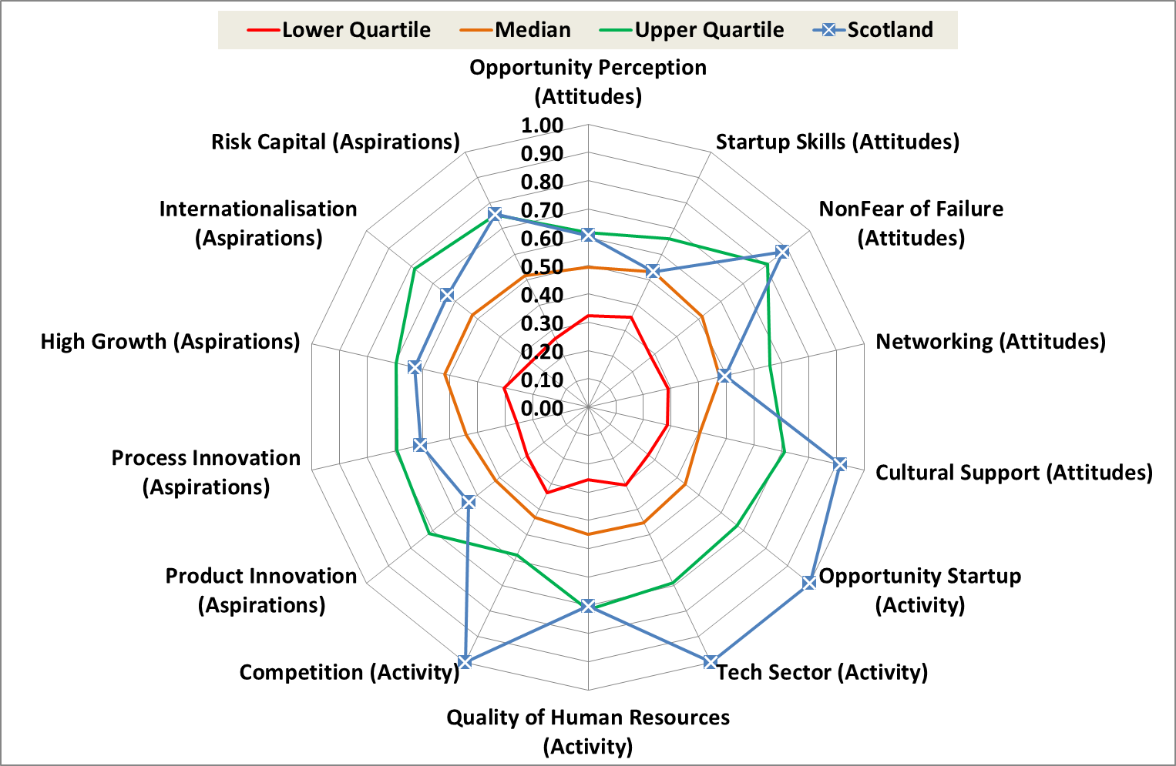

2012 to 2015 spider diagram for Scotland versus 73 countries

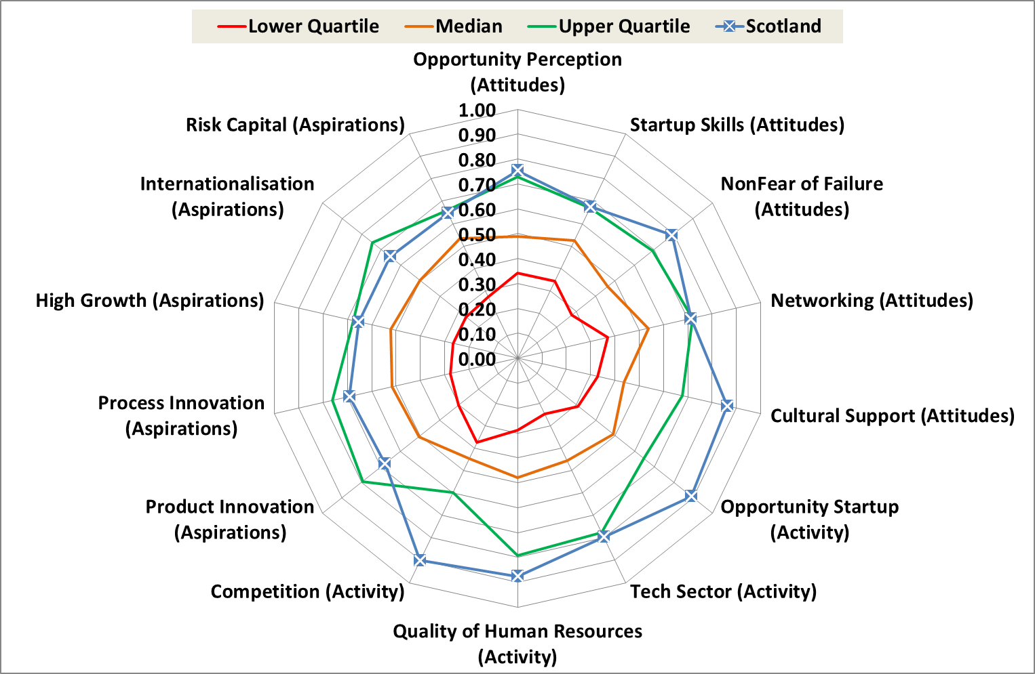

**Figures 3 and 4. Scotland compared to 28 innovation-driven countries**

Revised 2008 to 2011 spider diagram for Scotland versus 28 innovation-driven countries

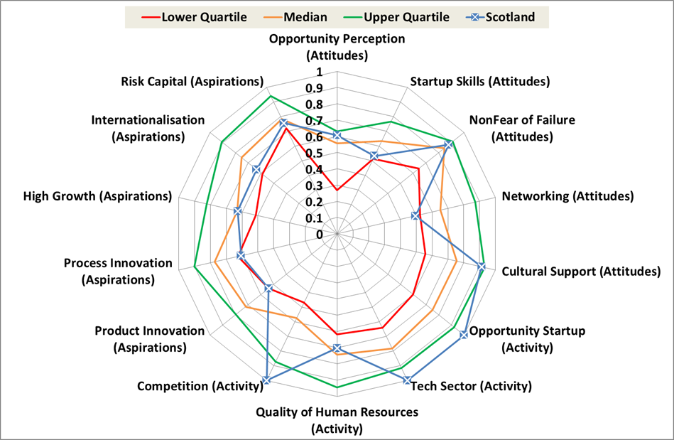

2012 to 2015 spider diagram for Scotland versus 28 innovation-driven countries

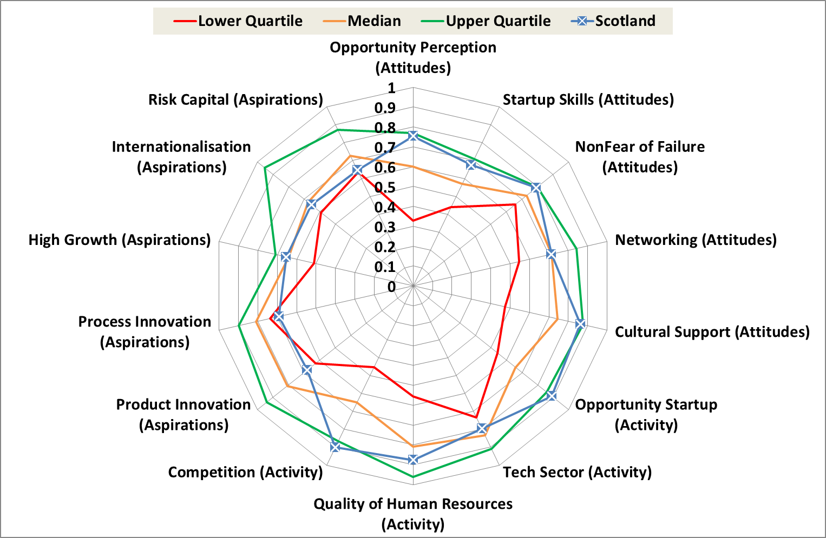

**Figures 5 and 6. Scotland compared to Arc of Prosperity countries**

Revised 2008 to 2011 spider diagram for Scotland versus five Arc of Prosperity countries

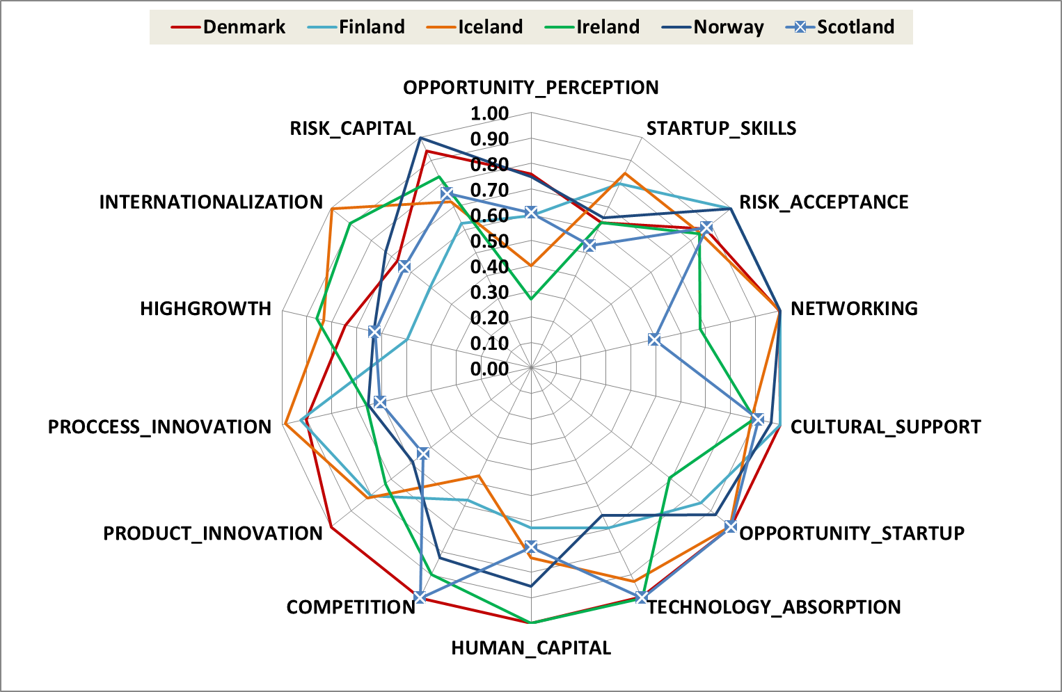

2012 to 2015 spider diagram for Scotland versus four Arc of Prosperity countries

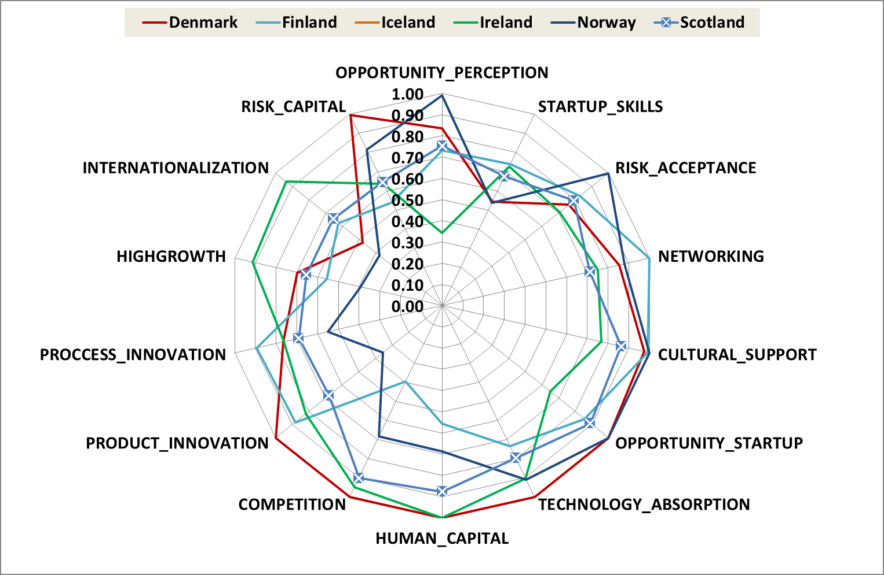

**Figures 7 and 8. Scotland compared to other UK home nations**

Revised 2008 to 2011 spider diagram for Scotland versus three home nations

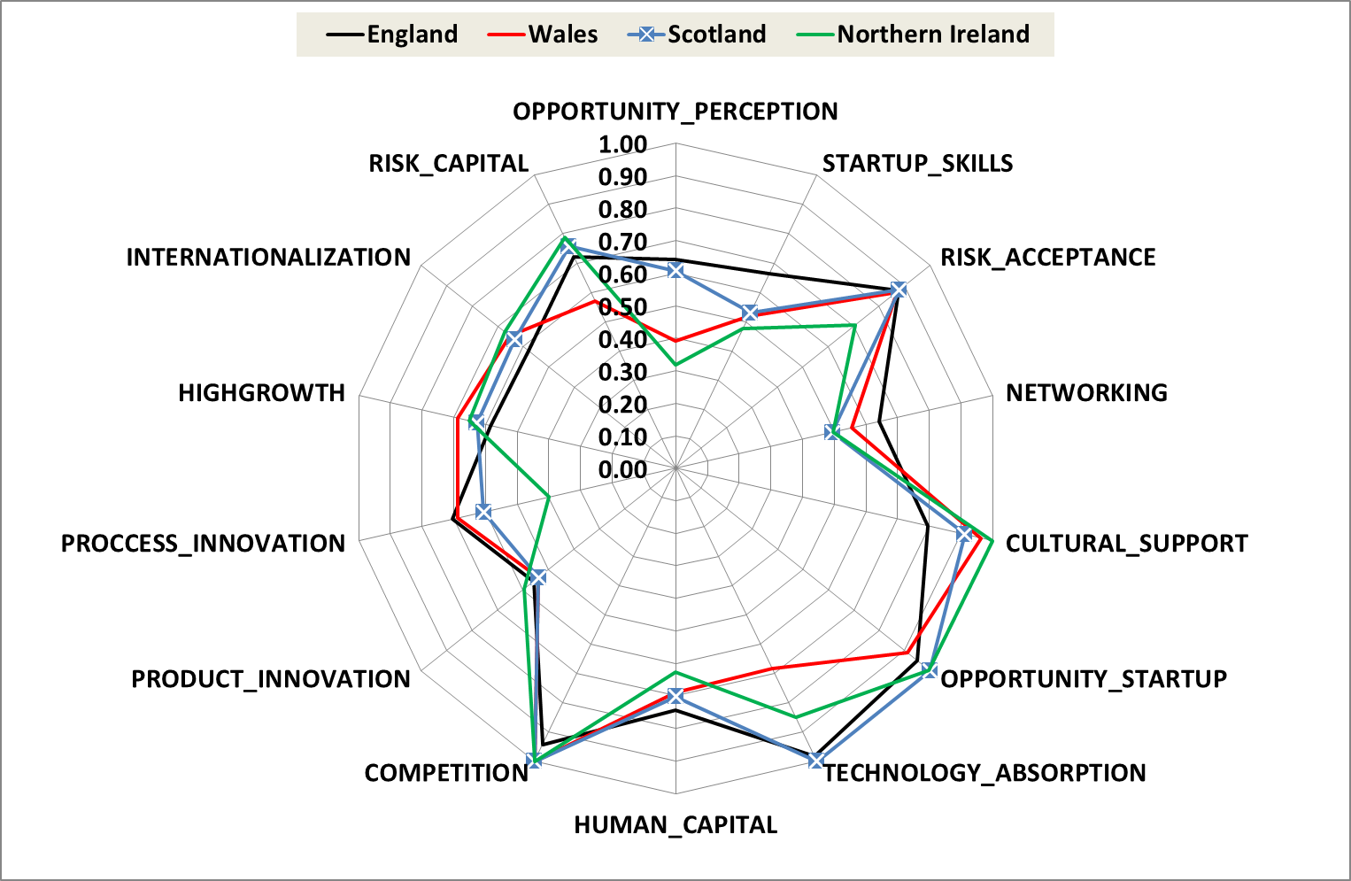

2012 to 2015 spider diagram for Scotland versus three home nations

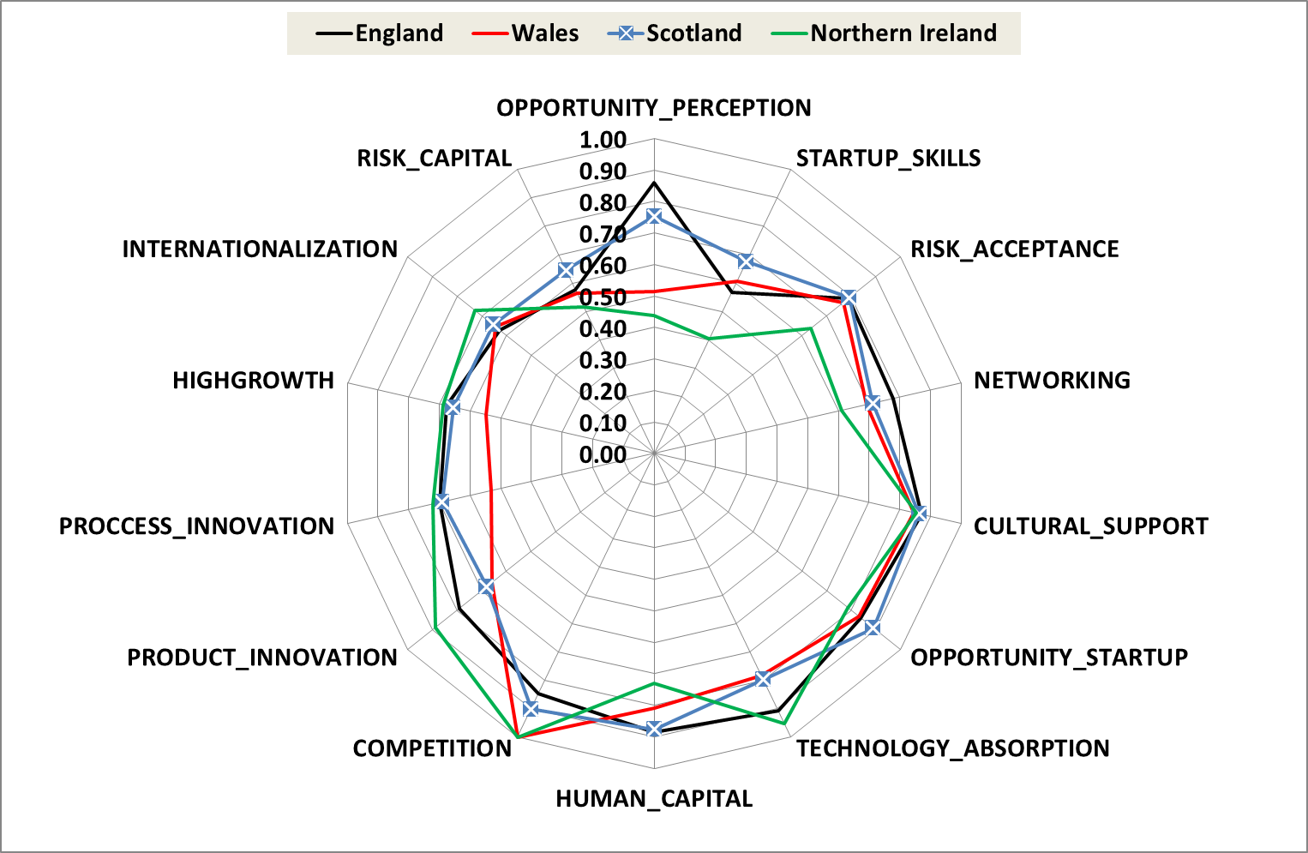

**Table 1. Institutional, Individual and pillar scores and ranks for 2008 to 2011 period, 73 countries**

|  |  |  |  |  |  |  |  |
| --- | --- | --- | --- | --- | --- | --- | --- |
| Top Quartile |  | Upper-middle Quartile |  | Lower-middle Quartile |  | Bottom Quartile |  |



**Table 2. Institutional, Individual and pillar scores and ranks for 2012 to 2015 period, 73 countries**

|  |  |  |  |  |  |  |  |
| --- | --- | --- | --- | --- | --- | --- | --- |
| Top Quartile |  | Upper-middle Quartile |  | Lower-middle Quartile |  | Bottom Quartile |  |



**Table 3. Institutional, Individual and pillar scores and ranks for 2008 to 2011 period, 28 innovation-driven countries**

|  |  |  |  |  |  |  |  |
| --- | --- | --- | --- | --- | --- | --- | --- |
| Top Quartile |  | Upper-middle Quartile |  | Lower-middle Quartile |  | Bottom Quartile |  |



**Table 4. Institutional, Individual and pillar scores and ranks for 2012 to 2015 period, 28 innovation-driven countries**

|  |  |  |  |  |  |  |  |
| --- | --- | --- | --- | --- | --- | --- | --- |
| Top Quartile |  | Upper-middle Quartile |  | Lower-middle Quartile |  | Bottom Quartile |  |



**Table 5. Sensitivity analysis showing which pillars extra resources should be focused on for a 30%, 10% or 5% improvement in Scotland’s relative position in the GEDI Index, 2008 to 2011 period**



**Table 6. Sensitivity analysis showing which pillars extra resources should be focused on for a 30%, 10% or 5% improvement in Scotland’s relative position in the GEDI Index, 2012 to 2015 period**



**Section 4. References**

Acs, Z. J., Autio, E., Szerb, L. (2014) National Systems of Entrepreneurship: Measurement issues and policy implications. Research Policy, 43: 476–494.

Anyadike-Danes, M., Bjuggren , C-M., Gottschalk, S., Hõlzl, W., Johansson, D. , Maliranta, M., and Myrann, A. (2015). An international cohort comparison of size effects on job growth. Small Business Economics 44: 821–844.

Autio, E., Kenney, M. F., Mustar, P., Siegel, D. S., & Wright, M. T. 2014. Entrepreneurial innovation: The importance of context. Research Policy, 43(7): 1097-1108.

Autio, E., Nambisan, S., Thomas, L., & Wright, M. 2018. Digital affordances, spatial affordances, and the genesis of entrepreneurial ecosystems. Strategic Entrepreneurship Journal, in print.

Autio, E., & Rannikko, H. 2016. Retaining winners: Can policy boost high-growth entrepreneurship? Research Policy, 45(1): 42-55.

Autio, E. and Levie, J. (2017) Managing Entrepreneurial ecosystems. In G. Ahmetoglu and T. Karcisky (eds.), Wiley Handbook of Entrepreneurship.pp.423-452. Chicester: John Wiley & Sons.

Bock, A., and Johnson, A. (2015). Entrepreneurial Ecosystems: Fixing the Triple Helix. European Business Review, November 20. Available at: http://www.europeanbusinessreview.com/entrepreneurial-ecosystems-fixing-the-triple-helix/

Feld B. 2012. Startup Communities: Building an Entrepreneurial Ecosystem in your City. Wiley: Hoboken, NJ.

Isenberg DJ. 2016. Applying the ecosystem metaphor to entrepreneurship: Uses and abuses. Antitrust Bulletin 61(4): 564-573.

Mason, C., & Brown, R. (2014). Entrepreneurial ecosystems and growth oriented entrepreneurship. Paris, France: OECD LEED Programme.

Olofunmilola, D., Jack, S, and George, M. (2016). University-business engagement franchising and geographic distance: A case study of a business leadership programme. Regional Studies 50(7):1217-1231.

Spigel, B. (2016) Developing and governing entrepreneurial ecosystems: The structure of entrepreneurial support programs in Edinburgh, Scotland. International Journal of Innovation and Regional Development 7 (2). 141-160.

Spigel, B. (2017a). The Relational Organization of Entrepreneurial Ecosystems. Entrepreneurship Theory & Practice 41: 49–72.

Spigel, B. (2017b). Entrepreneurial ecosystems as practices and resources: Resource acquisition and co-production in Edinburgh and Glasgow. Paper presented at Academy of Management Conference, Atlanta, August.

Spigel, B. and Harrison, R. (2017). Towards a theory of entrepreneurial ecosystems. Strategic Management Journal. In print.

World Economic Forum, 2014. Enhancing Europe's competitiveness: Fostering innovation-driven entrepreneurship in Europe, in: WEF (Ed.). World Economic Forum, Geneva, p. 64.

**Appendix 1. Original versus revised spider diagrams for 2008 to 2011**

Original 2008 to 2011 spider diagram for Scotland versus 78 countries

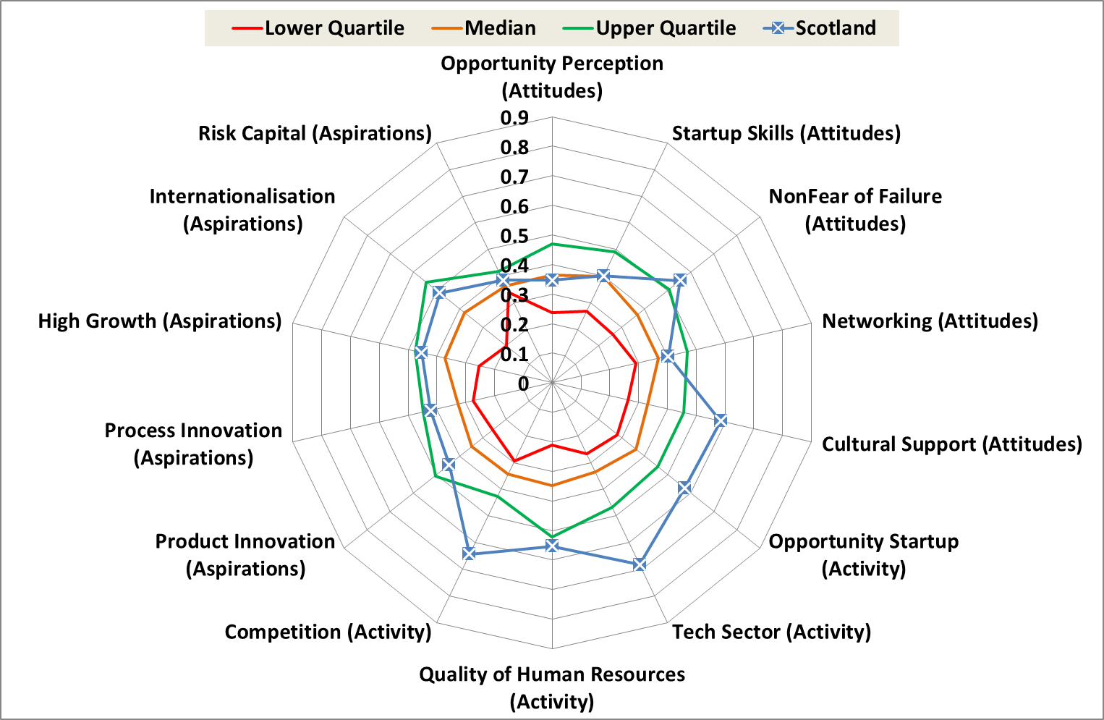

Revised 2008 to 2011 spider diagram for Scotland versus 73 countries



Original 2008 to 2011 spider diagram for Scotland versus 27 innovation-driven countries

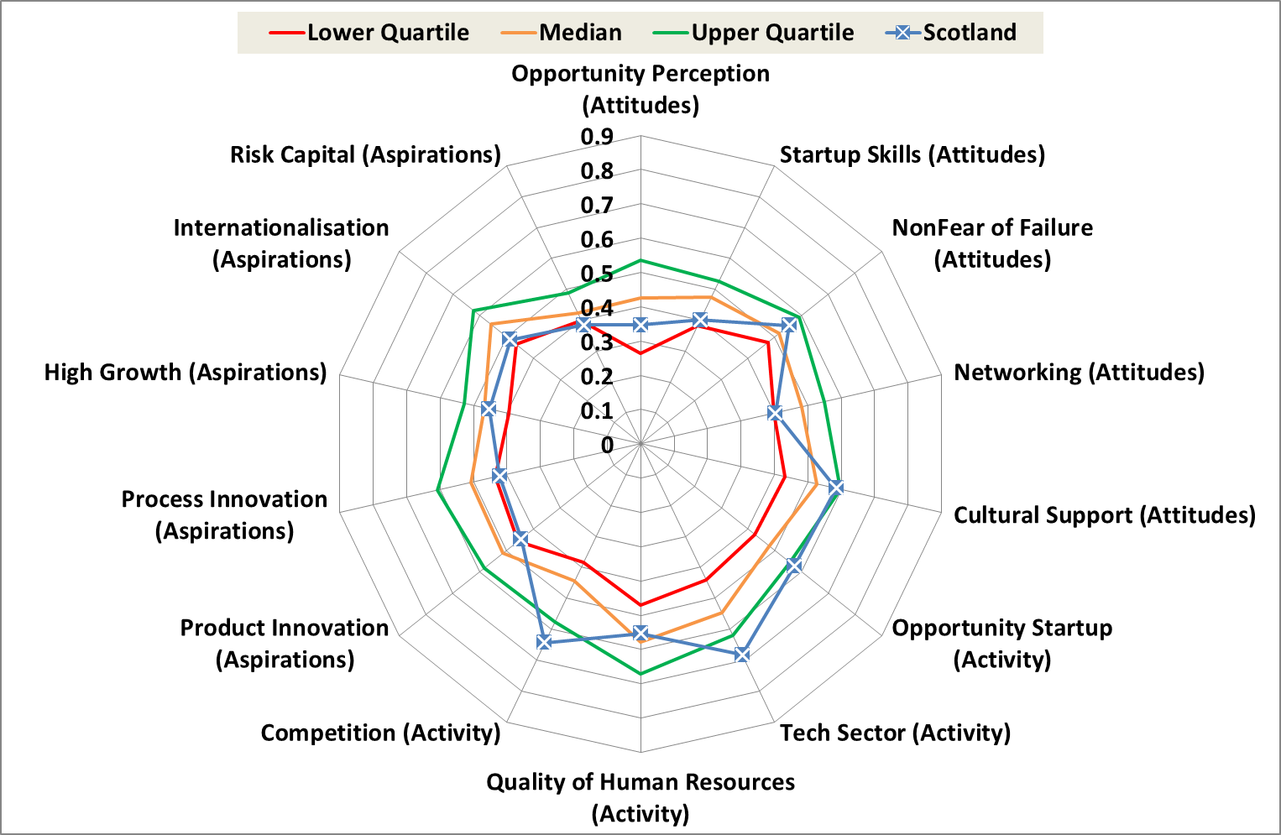

Revised 2008 to 2011 spider diagram for Scotland versus 28 innovation-driven countries

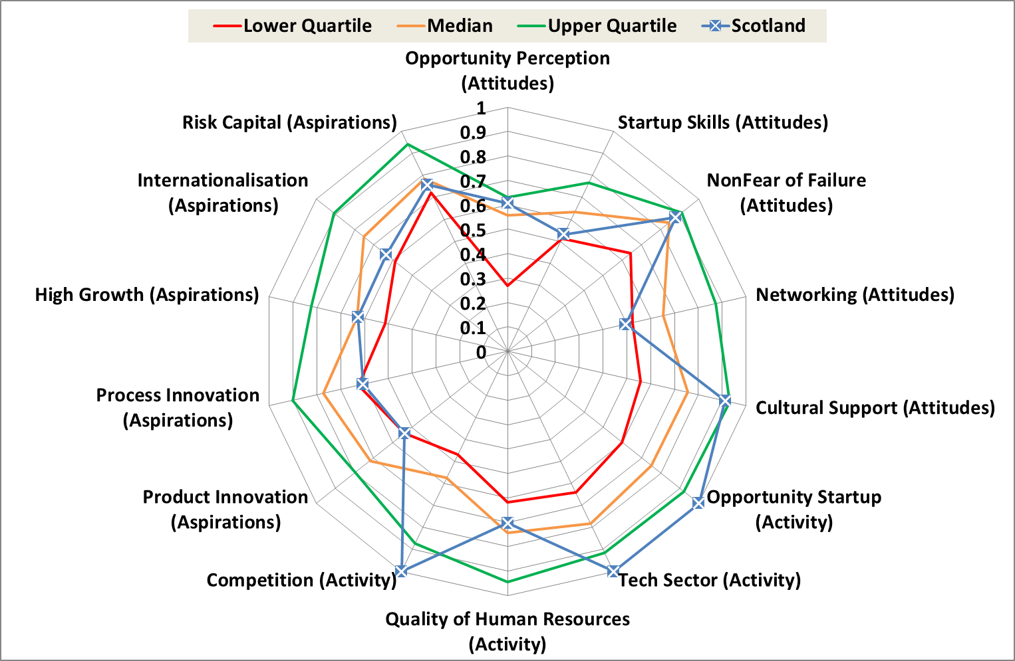

Original 2008 to 2011 spider diagram for Scotland versus five Arc of Prosperity countries

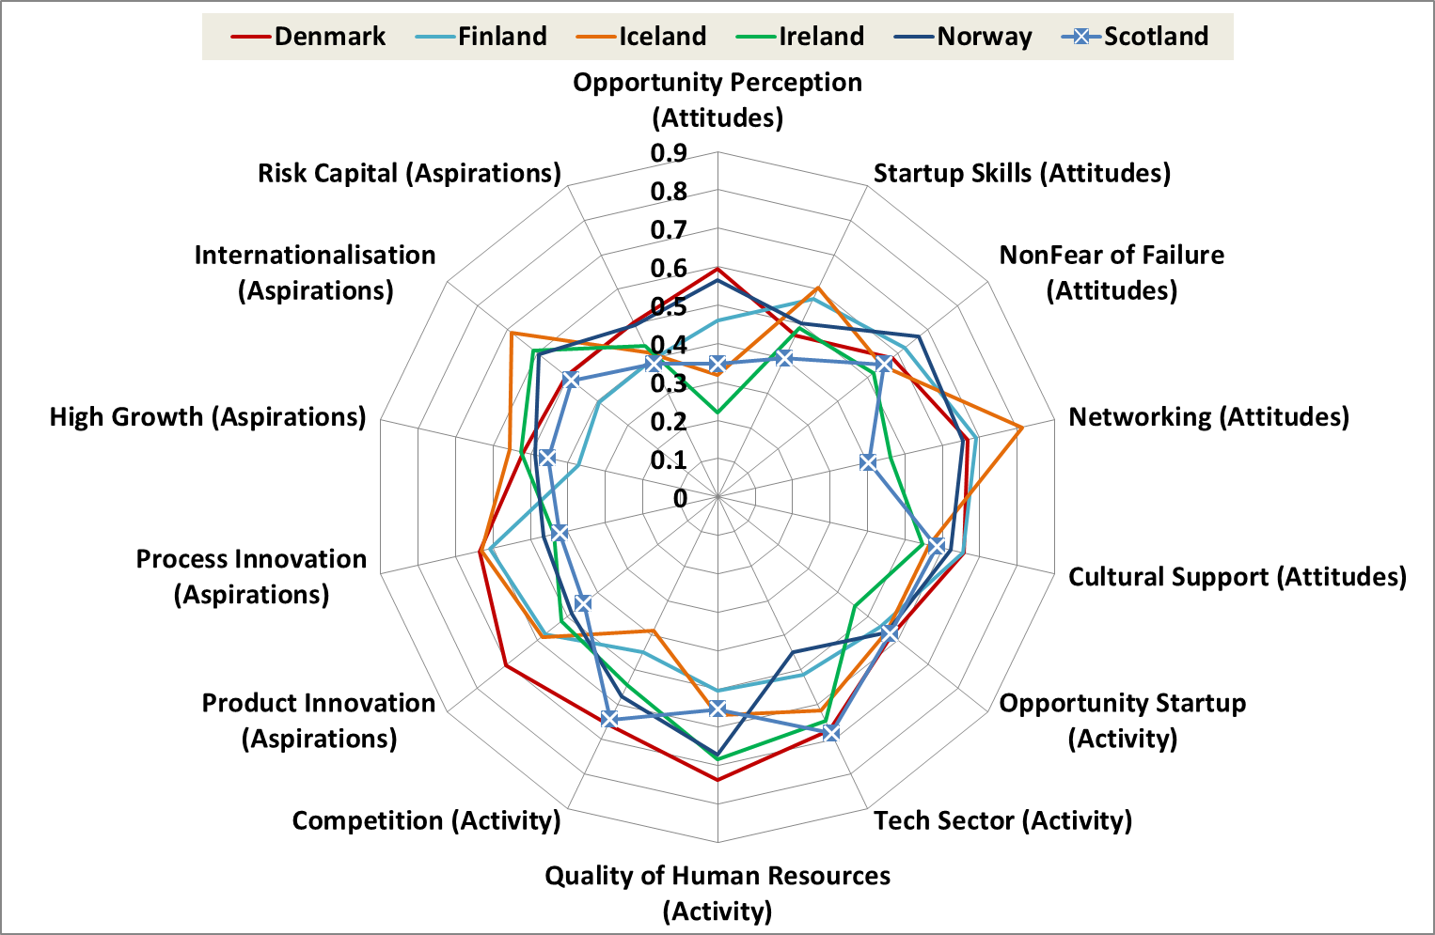

Revised 2008 to 2011 spider diagram for Scotland versus five Arc of Prosperity countries



Original 2008 to 2011 spider diagram for Scotland versus three home nations

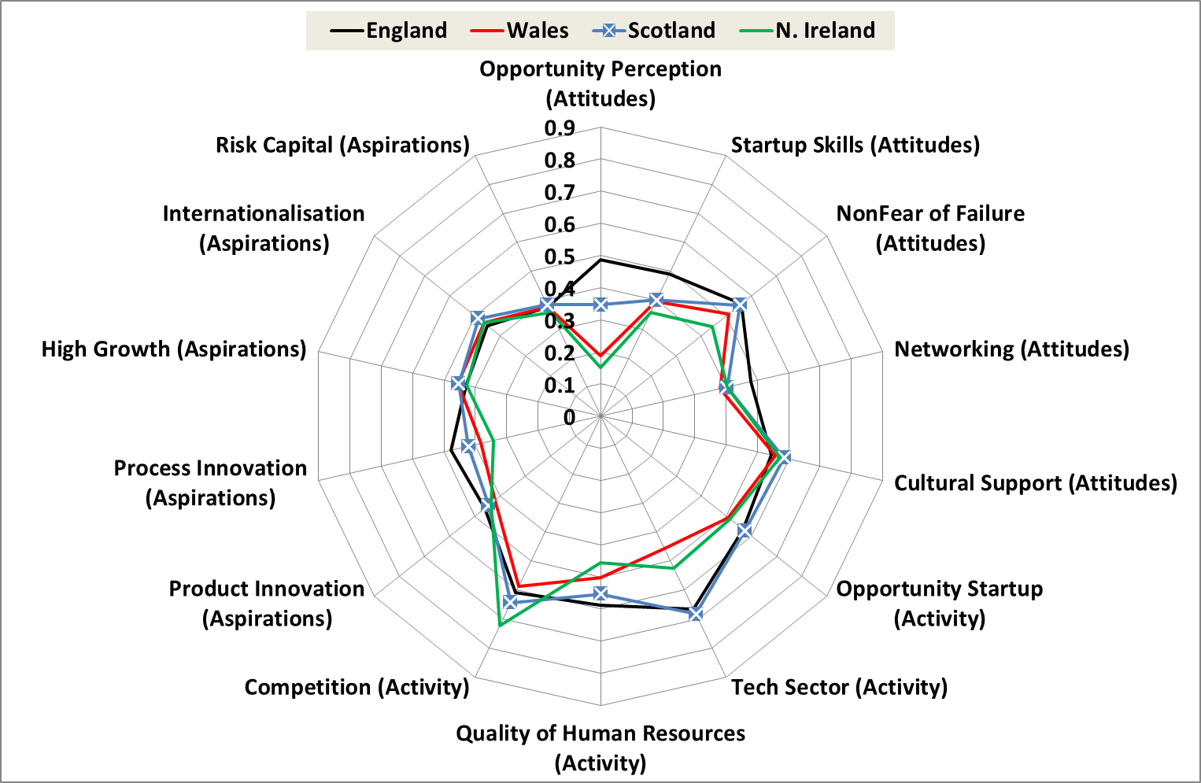

Revised 2008 to 2011 spider diagram for Scotland versus three home nations



# Appendix 2 GEDI Methodology and Calculation of the Scores for Scotland

**Appendix 2.1 Country sample**

Of the 83 countries available for 2008 to 2011 we have data for only 73 in 2012 to 2015. Since we intended to use as much data as possible we substituted the missing country data with similar type of countries in the second time period: Suriname for Dominican Republic, Bulgaria for Serbia, Luxembourg for Iceland, Libya for Syria, Vietnam for Bangladesh, and Qatar for United Arab Emirates. We excluded only four countries for which good substitutes were not available: Hong Kong, Jordan, Montenegro, and Saudi Arabia. Therefore the composition of countries in terms of development is broadly the same over the two periods.

**Table 1: Sample countries, and data availability**

|  |  |  |  |
| --- | --- | --- | --- |
| Countries | Data Availability 2008-2011 | Countries | Data availability 2012-2015 |
| Algeria | 2009, 2011 | Algeria | 2012-2013 |
| Angola | 2010 | Angola | 2012-2014 |
| Argentina | 2008-2011 | Argentina | 2012-2015 |
| Australia | 2010-2011 | Australia | 2014-2015 |
| Bangladesh | 2011 | Vietnam | 2013-2014 |
| Barbados | 2011 | Barbados | 2012-2015 |
| Belgium | 2008-2011 | Belgium | 2012-2015 |
| Bolivia | 2008, 2010 | Bolivia | 2014 |
| Bosnia and Herzegovina | 2008-2011 | Bosnia and Herzegovina | 2012-2014 |
| Brazil | 2008-2011 | Brazil | 2012-2015 |
| Chile | 2008-2011 | Chile | 2012-2015 |
| China | 2009-2011 | China | 2012-2015 |
| Colombia | 2008-2011 | Colombia | 2012-2015 |
| Costa Rica | 2010 | Costa Rica | 2012, 2014 |
| Croatia | 2008-2011 | Croatia | 2012-2015 |
| Czech Republic | 2011 | Czech Republic | 2013 |
| Denmark | 2008-2011 | Denmark | 2012, 2014 |
| Dominican Republic | 2008-2009 | Suriname | 2013-2014 |
| Ecuador | 2008-2010 | Ecuador | 2012-2015 |
| Egypt | 2008, 2010 | Egypt | 2012, 2015 |
| Finland | 2008-2011 | Finland | 2012-2015 |
| France | 2008-2011 | France | 2012-2014 |
| Germany | 2008-2011 | Germany | 2012-2015 |
| Ghana | 2010 | Ghana | 2012-2013 |
| Greece | 2008-2011 | Greece | 2012-2015 |
| Guatemala | 2009-2011 | Guatemala | 2013-2015 |
| Hungary | 2008-2011 | Hungary | 2012-2015 |
| Iceland | 2008-2010 | Luxembourg | 2013-2015 |
| India | 2008 | India | 2013-2015 |
| Iran | 2008-2010 | Iran | 2012-2015 |
| Ireland | 2008, 2010-2011 | Ireland | 2012-2015 |
| Israel | 2008-2010 | Israel | 2012-2013, 2015 |
| Italy | 2008-2010 | Italy | 2012-2015 |
| Jamaica | 2008-2011 | Jamaica | 2013-2014 |
| Japan | 2008-2011 | Japan | 2012-2014 |
| Korea | 2008-2011 | Korea | 2012-2013, 2015 |
| Latvia | 2008-2011 | Latvia | 2012-2013, 2015 |
| Lebanon | 2009 | Lebanon | 2015 |
| Lithuania | 2011 | Lithuania | 2012-2014 |
| Macedonia | 2008, 2010 | Macedonia | 2012-2013, 2015 |
| Malaysia | 2009-2011 | Malaysia | 2012-2015 |
| Mexico | 2008, 2010-2011 | Mexico | 2012-2015 |
| Morocco | 2009 | Morocco | 2015 |
| Netherlands | 2008-2011 | Netherlands | 2012-2015 |
| Nigeria | 2011 | Nigeria | 2012-2013 |
| Norway | 2008-2011 | Norway | 2012-2015 |
| Pakistan | 2010-2011 | Pakistan | 2012 |
| Panama | 2009, 2011 | Panama | 2012-2015 |
| Peru | 2008-2011 | Peru | 2012-2015 |
| Poland | 2011 | Poland | 2012-2015 |
| Portugal | 2010-2011 | Portugal | 2012-2015 |
| Romania | 2008-2011 | Romania | 2012-2015 |
| Russia | 2008-2011 | Russia | 2012-2014 |
| Serbia | 2008-2009 | Bulgaria | 2015 |
| Singapore | 2011 | Singapore | 2012-2014 |
| Slovakia | 2011 | Slovakia | 2012-2015 |
| Slovenia | 2008-2011 | Slovenia | 2012-2015 |
| South Africa | 2008-2011 | South Africa | 2012-2015 |
| Spain | 2008-2011 | Spain | 2012-2015 |
| Sweden | 2010-2011 | Sweden | 2012-2015 |
| Switzerland | 2009-2011 | Switzerland | 2012-2015 |
| Syria | 2009 | Libya | 2013 |
| Taiwan | 2010-2011 | Taiwan | 2012-2015 |
| Thailand | 2011 | Thailand | 2012-2015 |
| Trinidad and Tobago | 2010-2011 | Trinidad & Tobago | 2012-2014 |
| Tunisia | 2009-2010 | Tunisia | 2012, 2015 |
| Turkey | 2008, 2010-2011 | Turkey | 2012-2013 |
| Uganda | 2009-2010 | Uganda | 2012-2014 |
| UAE | 2009, 2011 | Qatar | 2014 |
| United Kingdom (full) | 2008-2011 | United Kingdom (full) | 2012-2015 |
| England | 2008-2011 | England | 2012-2015 |
| Wales | 2008-2011 | Wales | 2012-2015 |
| Scotland | 2008-2011 | Scotland | 2012-2015 |
| Northern Ireland | 2008-2011 | Northern Ireland | 2012-2015 |
| United States | 2008-2011 | United States | 2012-2015 |
| Uruguay | 2008-2011 | Uruguay | 2012-2015 |
| Zambia | 2010 | Zambia | 2012-2013 |

**Appendix 2.2 Methodology**

The GEDI scores for all countries are calculated according to the following eight points. Note that we calculate the GEDI scores for 73 countries both in the 2008-2011 and the 2012-2015 plus the four UK regions, England, Northern Ireland, Scotland and Wales resulting in 154 units of observations.

1. The calculation of the basic individual and institutional variable indicators was based on a simple average over the 2008-2011 and the 2012-2015 time period. Table 1 provides details about the availability of the yearly country data. We did not conduct data imputation for missing data.
2. ***The selection of variables:*** We start with the variables that come directly from the original sources for each country involved in the analysis. The variables are of two types: individual level (personal or business) and come from the Global Entrepreneurship Monitor (GEM) Adult Population Survey, and institutional/environmental level, and come from various other sources. Altogether we use 16 individual and 15 institutional variables, some of which are themselves complex. The description and the calculation of the individual variables are described in Appendix 2.4, and the institutional variables in Appendix 2.5.
3. ***The construction of the pillars:*** We calculate all pillars from the variables using the interaction variable method; that is, by multiplying the individual variable with the proper institutional variable. The notion behind this technique goes back to Baumol’s (1996) idea that the value of entrepreneurship depends on both the individual effort and the institutional context. This multiplication result for all the 554 observations is.

(1)

for all j = 1 ... k, the number of individual and institutional variables

is the original score value for country i and individual variable j

is the original score value for country i and institutional variable j

is the original pillar value for country i and pillar j

1. ***Normalization:*** pillar values were first normalized to a range from 0 to 1, using the distance method, as shown in equation 2:

(2)

for all j = 1 ... k, the number of pillars

where is the normalized score value for country i and pillar j

is the original pillar value for country i and pillar j

is the maximum value for pillar j

This normalization technique compares a given country’s performance to the best performing country. Hence, it provides a proper benchmark for evaluating the performance of a particular country in a certain pillar according to the best available practice. The disadvantage of the “min-max” methodology is that it assigns value one to the best country and zero to the worst one, which could exaggerate small differences. Another popular normalization method, the “z” score approach, guarantees normal distribution but results in a variable range of scores. Since we require that country scores be strictly in the [0,1] range, we cannot use this approach.

1. ***Capping:*** All index-building is based on a benchmarking principle. We selected the 95th percentile score adjustment, meaning that any observed values higher than the 95th percentile are lowered to the 95th percentile. We are using the same benchmarking for both the time periods that makes possible to compare the advances over time. This capping method has two advantages. First, it makes it possible to get rid of the outliers. Second, it provides a reasonable and reachable benchmark for the other countries. Without capping the best country benchmark value, a certain pillar could be extremely high, which would result in unreasonably lower normalized scores for the other countries.
2. ***Average pillar adjustment:*** The different averages of the normalized values of the indicators imply that reaching the same indicator values requires a different effort and resources. Since we want to apply GEI for public policy purposes, the additional resources to achieve the same marginal improvement of the pillar values should be the same for all pillars. However, the marginal effects could differ, depending on the level of the pillar values. Country variations in the marginal effects are also possible. Calculating all the marginal effects for all the countries would be a cumbersome task, so we suggest a simpler solution: to equalize the marginal effects of the components only on the average pillar values of all countries. This technique reduces but does not eliminate the distortion in calculating the marginal effects. Equation 3 shows the calculation of the average value of pillar :

(3)

We want to transform the values such that the potential values to be in the [0,1] range.

(4)

where k is the “strength of adjustment”, the k-th moment of is exactly the needed average,

We have to find the root of the following equation for k:

(5)

It is easy to see based on previous conditions and derivatives that the function is decreasing and convex which means it can be quickly solved using the well-known Newton-Raphson method with an initial guess of 0. After obtaining k, the computations are straightforward.

Note that if

that is k be thought of as the strength (and direction) of adjustment.

The average marginal rate of compensation (AMRC) for any two average pillars *i* and *j* is the same:

(6)

The adjusted pillar values are calculated for the both time period, combined.

1. ***Penalizing:*** After these transformations, the penalty for bottleneck methodology was used to create pillar-adjusted PFB values. A bottleneck is defined as the worst performing link or a binding constraint in a particular country’s system of entrepreneurship. Here, bottleneck means a shortage or the lowest level of a particular pillar, relative to other pillars. This notion of a bottleneck is important for policy purposes. Our model suggests that pillars interact; if they are out of balance, entrepreneurship is inhibited. The pillar values should be adjusted in a way that takes into account this notion of balance. After equalizing the pillar averages, the value of each pillar of a country is penalized by linking it to the score of the pillar with the weakest scores in that country. This simulates the notion of a bottleneck; if the weakest pillar were improved, the whole GEI would show a significant improvement.

We define our penalty function as:

(7)

where is the modified, post-penalty value of pillar j in country i

is the normalized value of index component j in country i

is the lowest value of for country i

i = 1, 2,……n = the number of countries

j = 1, 2,.……m = the number of pillars

0 ≤a, b ≤ 1 are the penalty parameters, the basic setup is a = b = 1

The penalty function also reflects compensation for the loss of one pillar with a gain in another pillar. Let us define the Marginal Rate of Compensation (MRC) as follows:

(8)

Full compensability means that a loss in one pillar can be compensated for by the same increase in another pillar. However, this is not realistic. The MRC is the same concept as the Marginal Rate of Substitution for goods and the Marginal Rate of Technical Substitution for inputs (Casadio-Tarabusi and Palazzi 2012), which are reflected in the law of diminishing return. Therefore, the effect of the change of the penalty is not proportional, which means that higher compensation is necessary for the loss in one pillar if the difference between another pillar value and the particular pillar is higher than the lower differences between the pillars. The required positive value of the second derivative means that the pillars are only partially compensable with each other, meaning that the penalty increases at an increasing rate:

(9)

Figure 1 pictures the size of the penalty when the minimum pillar value is 0.

Figure 1: Penalty Function, Penalized Values, and Pillar Values with No Penalty (ymin = 0; a, b = 1)

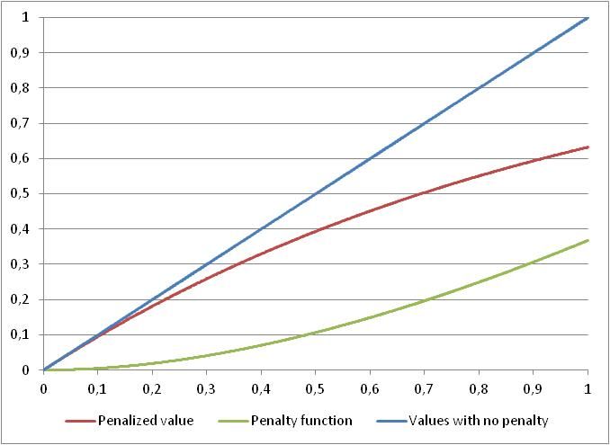

Note that we do not know the size of the penalty. To the best of our knowledge, no objective method exists to define the penalty function exactly. According to Figure 1, the maximum penalty is 0,368, which is about a one-third loss of the original value, which looks reasonable. Larger penalty values rearrange the ranking of the countries considerably.

1. **Sub-index calculation** The pillars are the basic building blocks of the sub-index: entrepreneurial attitudes, entrepreneurial abilities, and entrepreneurial aspirations. The value of a sub-index for any country is the arithmetic average of its PFB-adjusted pillars for that sub-index, multiplied by 100. The maximum value of the sub-indices is 100 and the potential minimum is 0, both of which reflect a country’s relative position in a particular sub-index.

where is the modified, post-penalty value of pillar j in country i

i = 1, 2,……n = the number of countries

j = 1, 2,.……14 = the number of pillars

1. **The Global Entrepreneurship Index calculation** The super-index, the Global Entrepreneurship Index, is simply the average of the three sub-indices. Since 100 represents the theoretically available limit, the GEI points can also be interpreted as a measure of the efficiency of the entrepreneurship resources

where i = 1, 2,……n = the number of countries

## Appendix 2.3 Calculation of the Individual and Institutional variables scores

In the GEDI publication we also provide data about the Individual and Institutional variables scores independently. These scores are calculated the same way as the GEI average pillar scores, repeating points 3-5. First, we normalize the variable scores for all the fourteen individual and institutional variables:

(12a)

(12B)

for all j = 1 ... k, the number of pillars (equal to the number of individual and institutional variables)

where is the normalized INDIVIDUAL score value for country i and pillar j

where is the normalized INSTITUTIONAL score value for country i and pillar j

is the original INDIVIDUAL variable value for country i and pillar j

is the original INSTITUTIONAL variable value for country i and pillar j

is the maximum value for INDIVIDUAL variable value in the case of pillar j

is the maximum value for INDSTITUTIONAL variable value in the case of pillar j

Second, we cap all the normalized individual and institutional variables. Similar to the GEI index score calculation we selected the 95th percentile score adjustment.

Third, we calculate the average adjusted individual and institutional variable pillar scores to equalize their average values. Equation 13a and 13b shows the calculation of the average value of the fourteen normalized and capped individual and institutional variables, respectively:

(13a)

(13b)

We want to transform the and the values such that the potential values to be in the [0,1] range.

(14a)

(14b)

where k is the “strength of adjustment”, the k-th moment of and is exactly the needed average, and

We have to find the root of the following equation for k:

(15a)

(15a)

Finally the individual and the institutional variables score for country *i* are calculated as the average of the average adjusted individual and institutional variables scores multiplied by 100

**Appendix 2.4. Description of the individual variables used in the GEDI**

|  |  |
| --- | --- |
| **Individual variable** | **Description** |
| Opportunity Recognition | The percentage of the 18-64 aged population recognizing good conditions to start business next 6 months in area he/she lives |
| Skill Perception | The percentage of the 18-64 aged population claiming to possess the required knowledge/skills to start business |
| Risk Acceptance | The percentage of the 18-64 aged population stating that the fear of failure would not prevent starting a business |
| Know Entrepreneurs | The percentage of the 18-64 aged population knowing someone who started a business in the past 2 years |
| Carrier | The percentage of the 18-64 aged population saying that people consider starting business as good carrier choice |
| Status | The percentage of the 18-64 aged population thinking that people attach high status to successful entrepreneurs |
| Career Status | The status and respect of entrepreneurs calculated as the average of Carrier and Status |
| Opportunity Motivation | Percentage of the TEA businesses initiated because of opportunity start-up motive |
| Technology Level | Percentage of the TEA businesses that are active in technology sectors (high or medium) |
| Educational Level | Percentage of the TEA businesses owner/managers having participated over secondary education |
| Competitors | Percentage of the TEA businesses started in those markets where not many businesses offer the same product |
| New Product | Percentage of the TEA businesses offering products that are new to at least some of the customers |
| New Tech | Percentage of the TEA businesses using new technology that is less than 5 years old average (including 1 year) |
| Gazelle | Percentage of the TEA businesses having high job expectation average (over 10 more employees and 50% in 5 years) |
| Export | Percentage of the TEA businesses where at least some customers are outside country (over 1%) |
| Informal Investment Mean | The mean amount of 3 year informal investment |
| Business Angel | The percentage of the 18-64 aged population who provided funds for new business in past 3 years excluding stocks & funds, average |
| Informal Investment | The amount of informal investment calculated as INFINVMEAN* BUSANG |

**Appendix 2.5 Description and source of the institutional variables used in the GEDI**

|  |  |  |  |
| --- | --- | --- | --- |
| **Institutional Variable** | **Description** | **Source**  **of Data** | **Data Availability** |
| Domestic Market | Domestic market size that is the sum of gross domestic product plus value of imports of goods and services, minus value of exports of goods and services, normalized on a 1–7 (best) scale data are from the World Economic Forum Competitiveness | World Economic Forum | The Global Competitiveness Report 2014-2015, p. 514 |
| Urbanization | Urbanization that is the percentage of the population living in urban areas, data are from the Population Division of the United Nations, 2014 revision | United Nations | http://esa.un.org/unpd/wup/DataSources/ |
| Market Agglomeration | The size of the market: a combined measure of the domestic market size and the urbanization that later measures the potential agglomeration effect. Calculated as domestic market urbanization* | Own calculation | - |
| Tertiary Education | Gross enrolment ratio in tertiary education, 2013 or latest available data. | UNESCO | http://data.uis.unesco.org/?queryid=142 |
| Business Risk | The business climate rate “assesses the overall business environment quality in a country…It reflects whether corporate financial information is available and reliable, whether the legal system provides fair and efficient creditor protection, and whether a country’s institutional framework is favorable to intercompany transactions” (http://www.trading-safely.com/). It is a part of the country risk rate. The alphabetical rating is turned to a seven-point Likert scale from 1 (D rating) to 7 (A1 rating). December 31, 2014 data | Coface | http://www.coface.com/Economic-Studies-and-Country-Risks/Comparative-table-of-country-assessments |
| Internet Usage | The number of Internet users in a particular country per 100 inhabitants, 2014 data | International Telecommunication Union | http://www.itu.int/en/ITU-D/Statistics/Pages/stat/default.aspx |
| Corruption | The Corruption Perceptions Index (CPI) measures the perceived level of public-sector corruption in a country. “The CPI is a ‘survey of surveys’, based on 13 different expert and business surveys.” (http://www.transparency.org/policy_research/surveys_indices/cpi/2009 ) Overall performance is measured on a ten-point Likert scale. Data are from 2014. | Transparency International | http://www.transparency.org/cpi2014 |
| Economic Freedom | “Business freedom is a quantitative measure of the ability to start, operate, and close a business that represents the overall burden of regulation, as well as the efficiency of government in the regulatory process. The business freedom score for each country is a number between 0 and 100, with 100 equaling the freest business environment. The score is based on 10 factors, all weighted equally, using data from the World Bank’s *Doing Business* study.” (<http://www.heritage.org/Index/pdf/Index09_Methodology.pdf>). Data are from 2013. | Heritage Foundation/  World Bank | http://www.heritage.org/index/explore |
| Tech Absorption | Firm-level technology absorption capability: “Companies in your country are (1 = not able to absorb new technology, 7 = aggressive in absorbing new technology)” | World Economic Forum | The Global Competitiveness Report 2014-2015, p. 507 |
| Staff Training | The extent of staff training: “To what extent do companies in your country invest in training and employee development? (1 = hardly at all; 7 = to a great extent)” | World Economic Forum | The Global Competitiveness Report 2014-2015, p. 463 |
| Market Dominance | Extent of market dominance: “Corporate activity in your country is (1 = dominated by a few business groups, 7 = spread among many firms)” | World Economic Forum | The Global Competitiveness Report 2014-2015, p. 467 |
| Technology Transfer | These are the innovation index points from GCI: a complex measure of innovation, including investment in research and development (R&D) by the private sector, the presence of high-quality scientific research institutions, the collaboration in research between universities and industry, and the protection of intellectual property | World Economic Forum | The Global Competitiveness Report 2014-2015, p. 20 |
| GERD | Gross domestic expenditure on R&D (GERD) as a percentage of GDP, year 2013 or latest available data; Puerto Rico, Dominican Republic, United Arab Emirates, and some African countries are estimated using regional or nearby country data. | UNESCO | <http://stats.uis.unesco.org/unesco/TableViewer/tableView.aspx?ReportId=2656> |
| Business Strategy | Refers to the ability of companies to pursue distinctive strategies, which involves differentiated positioning and innovative means of production and service delivery | World Economic Forum | The Global Competitiveness Report 2014-2015, p. 20 |
| Globalization | A part of the Globalization Index measuring the economic dimension of globalization. The variable involves the actual flows of trade, foreign direct investment, portfolio investment, and income payments to foreign nationals, as well as restrictions of hidden import barriers, mean tariff rate, taxes on international trade, and capital account restrictions. Data are from the 2013 report and based on the 2011 survey. <http://globalization.kof.ethz.ch/> | KOF Swiss Economic Institute | Dreher, Axel (2006): [Does Globalization Affect Growth? Evidence from a new Index of Globalization](http://129.3.20.41/eps/dev/papers/0210/0210004.pdf), Applied Economics 38, 10: 1091-1110. |
| Depth of Capital Market | The depth of capital market is one of the six sub-indices of the Venture Capital and Private Equity Index. This variable is a complex measure of the size and liquidity of the stock market, level of IPO, M&A, and debt and credit market activity. Note that there were some methodological changes over the 2006-2014 time period, so comparison to previous years is not perfect. The dataset is provided by Alexander Groh.*  For missing data nearby country data used. For countries having estimated individual data, DCM data are the same way as it is in the case of individual variables (see Table 2 last column) | EMLYON Business School, France and IESE Business  School, Barcelona, Spain | Groh et al (2012) |

*Special thanks for Alexander Groh and his team about the provision of the Depth of Capital Market data.